NOISE DETECTION AND ALERTING FOR SMARTCITY USING IOT
An Internship project
Submitted by
K.Ananthbabu K.Harshavardhan (18481A0489) (18481A0486)
K.Nirmagna K.Abhiram (18481A0490) (18481A0487)
K.Jagadeesh (18481A0485)

INTRODUCTION
Overview:

The overview of our project is to design a Noise detecting and alerting system for smart city using IOT. Generally IOT enables the connectivity, accessibility and tasking sensors to enable the citizens to access the real time information on noise levels. Smart cities should be planned in accordance with the noise detection and alerting to the areas to achieve the better level of control over the noise.

Purpose:
The main purpose of the Noise detection and alerting to smart cities is to provide the necessary information to ensure the detecting the noise and intimating through the web application services which are web and mobile software provides hourly, daily, weekly, and monthly reports of the noise level values and alerting messages. The project purpose is not only measures the noise levels and provides the data to the municipal authorities to plan for interventions to reduce the environmental noise but also it finds where the noise occurs with the help of maps which we used in the node red platform. So, this is the purpose of Noise detection and alerting to smart cities using IOT.

LITERATURE SURVEY
Existing problem:
Environmental noise is increasing year after year and becoming a growing concern in smart cities, since it does not cause problem to citizens, but also harmful effects to people. Finally it is worth to mention that noise effect the social and economic aspects. So, we have to solve the problem by find a better solution.
Proposed solution:
In this project, we find a smart solution to the above mentioned problem, making use of the Internet Of Things (IOT). The solution is such that, the noise levels will be recorded by the sensors, and the data will be sent to mobile application which we built using MIT app inventor installed in the person mobile. We also provide the locations from where the noise is coming and informing to the higher authorities on a particular day or alerting the people of current location of the using Google Maps.

THEORITICAL ANALYSIS

Block diagram:
FAST2SMS
IOT Devices
IBM Watson IOT Platform
WEB UI
Node Red
USER
Python Code
Cloudant DB
MIT APP

Fig.1: Proposed block model

Flow chart

START

System check and connection start
Store Info in Storage Server
Noise Recording
Noise level Detection
Report Noise level+ Location
Is Noise level >dB
no no
yes
Is noise occurrence>=10db
yes
Increment Noise Occurrence by 1

Result
The output of this noise detection is provided using a web application. The Detecting system which is having sensors will be fitted at different locations in the city or an area such as hospitals, highways, parks, homes and malls etc. Sensor continuously senses the level of the noise and gives the results in the (dB).
The indication will be given to a device by alert message which is sent to their mobile application with the help of fast 2 SMS application. This application can be used to get the knowledge regarding noise detection and controlling in the smart cities and then common people can take relative steps and measure accordingly.

Advantages
1. These are used for security systems.
2. Often it works with speech recognition software where in sound is convert to text.
3. It is easy to manipulate sound in real time. Hence earlier recording is not needed.
4. These can be easily affordable.
5.This helps in improving safety using noise alerting system based on noise level.
Disadvantages
1. Noise files require more memory size.
2. Noise recognition software is not very accurate compare to manual typing.
3. Often noise sensors are required to be mounted on cards for specific applications. This increases use of hardware.

Applications

1. Security system for office or Home
2. Spy Circuit
3. Home automation
4. Robotics
5. Smart Phones
6. Noise level recognition (not capable to obtain the dB value)

Conclusion

In this report we presented Noise detection and alerting to the smart cities project aimed at developing a noise detecting network to enable the citizens as well as government bodies to gain awareness towards the problem regarding noise and its social implications.
We discussed our approach and supporting a prototype implementation. While this project is in early stage we are planning to open with first public experiment soon to evaluate the user experience and generated noise map locations at which the noise is detected and it gives the alerts to the smart cities.

Future Scope
The work has shown that a good noise detection rate has reached, even under important noise degradation conditions. The study is presently going on, taking more complex and real noise level and also providing the locations from the noise is occurred. At the system level, detection precision improvement and rejection of any other disturbances of considered areas, will be examined.

Bibliography
- Shadrach Tunde, Akinkaude, Kowawole, Peter Fasae, “A Survey of Noise Pollution in Ado- Ekiti Metropolis Using Mobile Phone,” Science.
- . Sheng-Chieh Lee, Jhing - Fa Wan, G and Miao-Hia Chen, "ThresholdBasedNoise Detection and Reduction for Automatic Speech Recognition System in Human-Robot Interactions", Sensors, vol. 18, no. 7, 2018.

APPENDIX

SOURCE CODE:
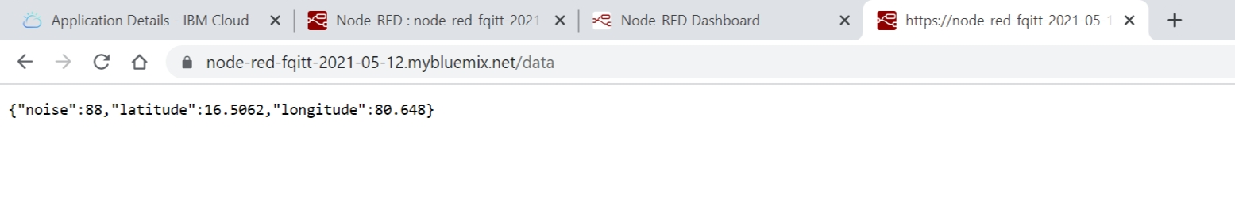

UI Output Screenshot:
